# **OPTIMISING TIME-LIMITED NON-PHARMACEUTICAL INTERVENTIONS FOR COVID-19 EPIDEMIC CONTROL**

**RESULTS**

Five different strategies were considered to explore the impact of differing lockdown measures on the trajectory of a COVID-19 epidemic curve (**Figure 1**). Each of these differ with regard to the “shape” of *β(t)* reductions over the explored intervention duration. Exact mathematical formulation of each scenario can be found in the ***Methods*** section.

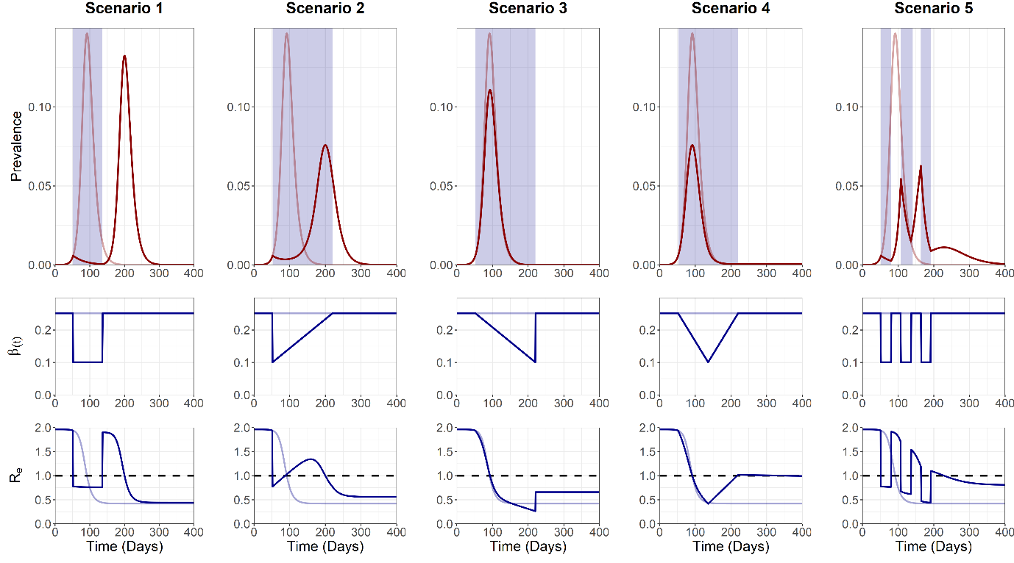

**Figure 1. Trajectory plots for the epidemic curve, intervention associated *β(t)* reductions and *Re*, for the five intervention scenarios**. Opaque red and blue lines depict unmitigated epidemic curve dynamics.Blue shading on the trajectory plot indicates the period of the intervention. Dotted line on the *Re* plot denotes the threshold for sustained epidemic growth.

Scenario 1 and 2 resulted in the suppression of the epidemic following the initiation of lockdown measures, with a resurgent 2nd peak occurring after the cessation of the intervention, with Re > 1. This can be attributed to the large pool of remaining susceptibles following the cessation of the intervention due to strong initial lockdown measures. In contrast, a mitigated single epidemic peak was observed for scenario 3 and 4 due to the effects of population immunity and “ramping up” of *β(t)* reductions, gradually suppressing *Re* < 1 and allowing a single epidemic peak to occur. The pulsed nature of scenario 5 allowed for brief opportunities for the build-up of population immunity (*Re* > 1) and subsequent epidemic control (*Re* < 1).

**Analysis 2**

A sensitivity analysis was next conducted to observe the sensitivity of each scenario to two outcome measures: 1) The maximum *I(t)* peak, *Imax*, and 2) the total cumulative incidence, *Ic(∞)*. These outcome measures were explored in relation to three model parameters: 1) Intervention trigger day (*tp*), 2) Magnitude of the intervention (*cmin*) and 3) The intervention duration (*dt*). Each sensitivity analysis was conducted with all other parameters held at baseline levels (**Figure 2**).

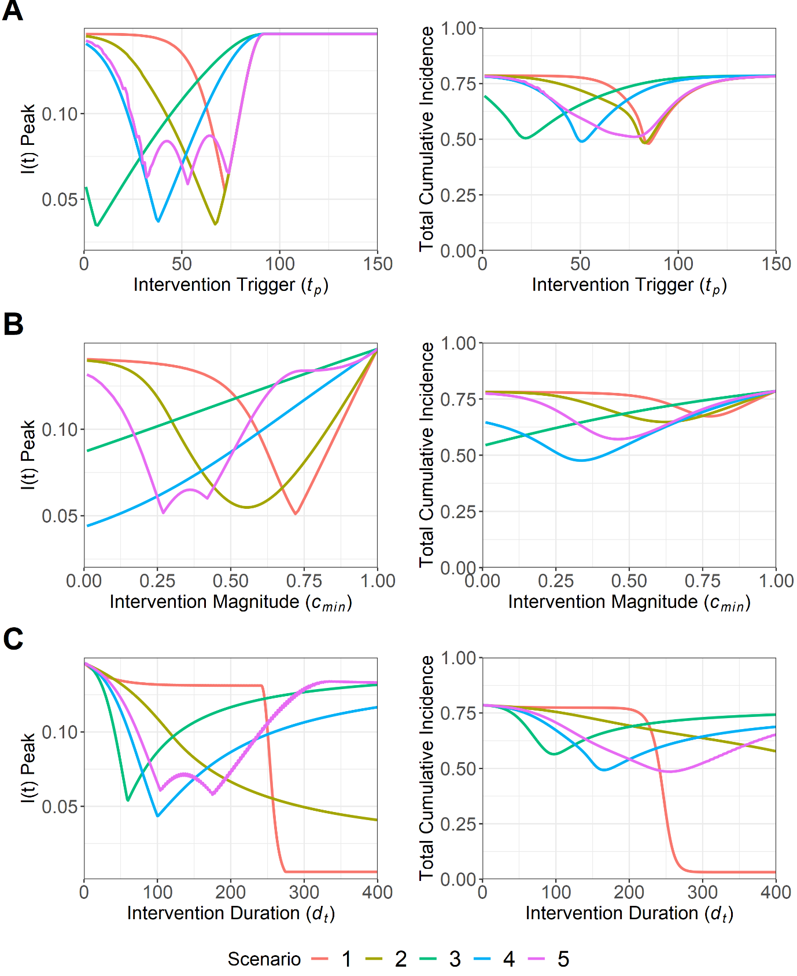

**Figure 2. Sensitivity analysis for maximum *I(t)* peak, *Imax*, and total cumulative incidence, *Ic(∞)*, for the five intervention scenarios. This was conducted for the following model parameters: A) Intervention trigger day (*tp*), B) Magnitude of lockdown measures (*cmin*) and C) Intervention duration (*dt*)**. Note that for A) and B) scenarios are comparable for a specific explored parameter value, with the duration of scenario 2, 3, 4 and 5 being doubled to ensure similar intervention magnitudes across all scenarios. This was not possible for C) as *dt* remains fixed across all scenarios.

A range of low-intermediate optimal trigger points (7 ≤ *tp* ≤ 74) to minimise *Imax* were identified across all scenarios (**Figure 2A)**. These optimums were highly sensitive to suboptimal deviations in scenario 1, 2, 3 and 4, with steep increases in *Imax* as the trigger point deviated either side of the optimal value. This suggests that intervening too early/late makes little difference in the context of preventing increases in *Imax* and *Ic(∞)* with a poorly timed, suboptimal intervention. In contrast, an early intervention was more beneficial to minimise *Imax* and *Ic(∞)* for scenario 3, and with a large range of optimal trigger points being observed for scenario 5 (32 < *tp* < 74).

Stronger interventions were more optimal to minimise *Imax* and *Ic(∞)* for scenario 3 and 4 **(Figure 2B)**. In contrast, scenario 1, 2 and 5 were able to minimise both outcome measures using an intermediate strength intervention (0.27 ≤ *cmin* ≤ 0.72). We note that despite the optimums observed for scenario 1, 2 and 5, it was still more beneficial to intervene too strongly than insufficiently, with lower suboptimal *cmin* values being more capable of minimising *Imax* and *Ic(∞)*, than comparable suboptimal values of *cmin* which were too high.

Longer intervention durations were found to be optimal to reduce *Imax* and *Ic(∞)* for scenario 1 and 2(**Figure 2C**). Intermediate length interventions were found to be optimal for all other scenarios (60 ≤ *dt* ≤ 175). However, we note that if a suboptimal intervention duration is introduced, it is more beneficial to intervene for too long, with increases in *Imax* and *Ic(∞)* being less severe in an intervention that is longer than optimal, compared to an intervention that is shorter.

**Analysis 3**

To explore the interplay between multiple model parameters, a sensitivity analysis was next conducted to identify the optimal parameter space to minimise *Imax* and *Ic(∞)* for a multi-dimensional parameter space: 1) Intervention trigger day (*tp*) and 2) Intervention duration (*dt*) (**Figure 3**).

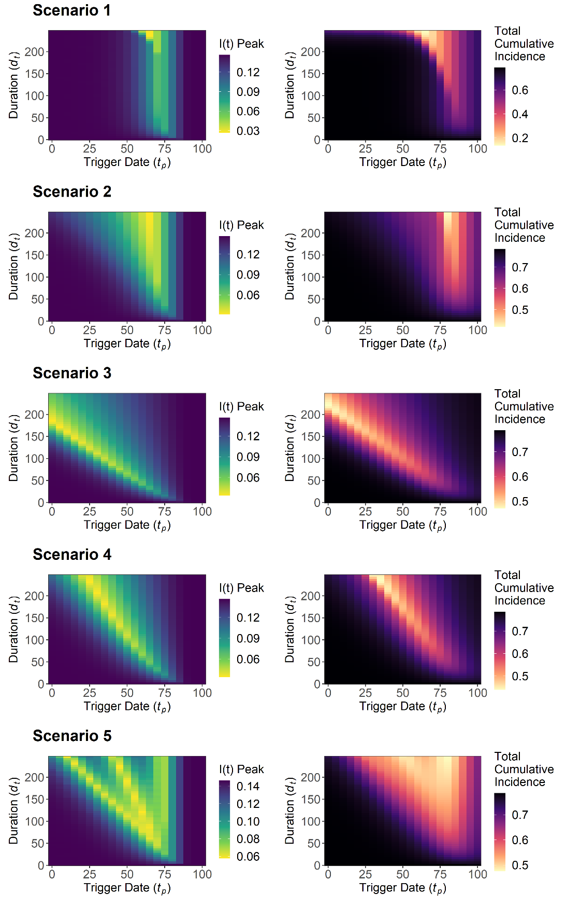

**Figure 3. Sensitivity analysis for maximum *I(t)* peak, *Imax*, and total cumulative incidence, *Ic(∞)*, for intervention trigger day, *tp*, and the intervention duration, *dt*. This was explored for the five intervention scenarios.** Note that for a specific value of *dt*, scenario 1 is not comparable with scenario 2, 3, 4 and 5 due to the need to double *dt* for the latter scenarios to ensure a comparable intervention magnitude over the intervention duration. This is not possible for this sensitivity analysis with *dt* being a fixed explored parameter and heatmap legends will differ across scenarios.

A long intervention duration (*dt* > 200) and an intermediate trigger point (*tp* = 65) was optimal for scenario 1 and 2 to minimise *Imax* and *Ic(∞)*. However, once the optimal intervention trigger was achieved, a large range of intervention durations could be selected with negligible impact on either outcome measure (10 ≤ *dt* ≤ 200). A different qualitative pattern was observed in scenario 3 and 4, with decreases to the intervention duration being necessary to maintain the optimal parameter space with a later intervention trigger. Rough qualitative agreement was found between the overall optimal parameter space for both outcome measures across all scenarios.

Increasing the length of the intervention was found to compensate for suboptimal choices of the intervention trigger in scenario 2, 3, 4 and 5, with both *Imax* and *Ic(∞)* being less sensitive to deviations from the optimal intervention trigger point as the duration of the intervention was increased. We also note the existence of suboptimal trigger point “gaps” in scenario 5, with increases and decreases in *Imax* as the trigger point was varied, resulting from the fixed periods between pulsed interventions increasing as *dt* increases. The size of these gaps widened as the intervention duration increased and were less pronounced for *Ic(∞)* relative to *Imax*.

The sensitivity analysis was repeated with *cmin* = 0.25/0.5/0.75 to assess the sensitivity of the *dt*/*tp* relationship to alterations to the magnitude of the intervention (**Figure S3 + 4**). Low-intermediate *cmin* values of 0.25 (scenario 1, 2 and 3) and 0.5 (scenario 3 and 4) were found to be more optimal to minimise *Imax*, with the lowest explored value of *cmin* being optimal to minimise *Ic(∞)* for all scenarios.

**Analysis 4**

Two sequentially implemented lockdown measures were introduced for each of the five scenarios to explore the impact of multiple interventions on the trajectory curve of the simulated COVID-19 epidemic. The lockdown-related scaling factor was kept static at baseline for both interventions *cmin1* = *cmin2* = 0.4. Baseline duration for intervention 1 and 2 was set at *dt1* = *dt2* = 42 days (6 weeks) for scenario 1, and *dt1* = *dt2* = 84 days (12 weeks) for scenario 2, 3, 4 and 5. The intervention trigger point was set at *tp1* = *tp2* = 42 days for both interventions, with *dt2* being defined relative to the end of intervention 1 (**Figure 4**).

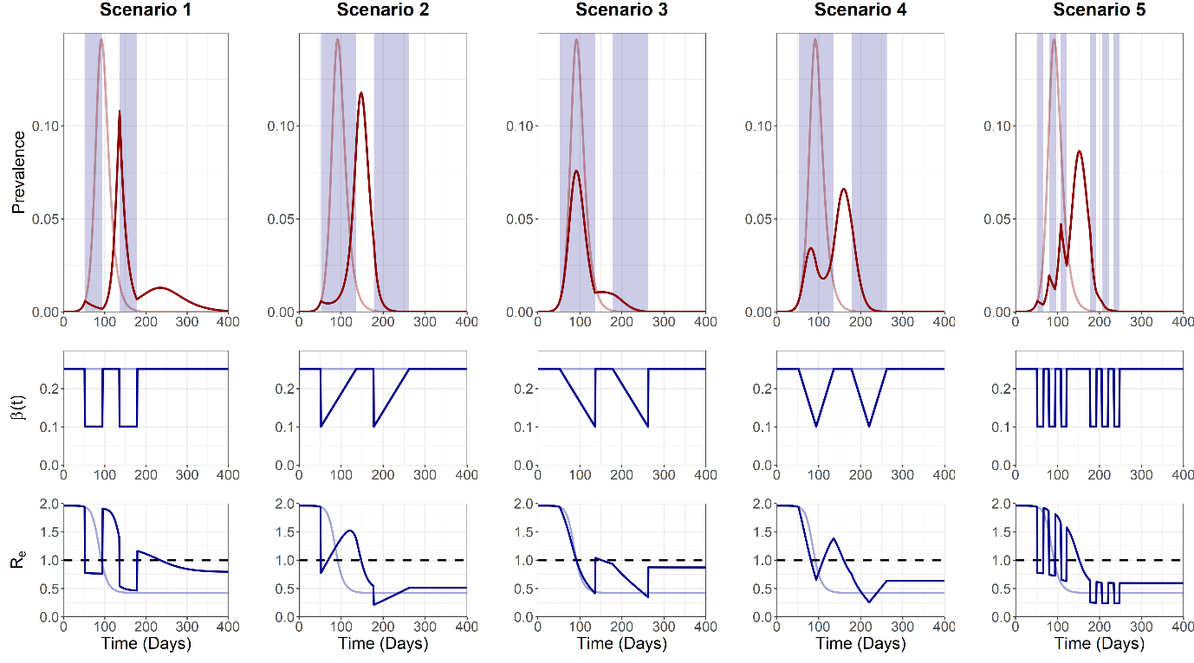

**Figure 4. Trajectory plots for the epidemic curve, intervention associated R0 reductions and Re, for the five “double” intervention scenarios.** Opaque red and blue lines depict unmitigated epidemic curve dynamics.Blue shading on the trajectory plot indicates the period of the intervention. Dotted line on the *Re* plot denotes the threshold for sustained epidemic growth.

We note the occurrence of a large second epidemic peak in scenario 1 and 2, with *Re* increasing substantially above 1 between interventions. A third epidemic peak was also observed due to the strong *β(t)* reductions imposed by scenario 1, with *Re* > 1 occurring transiently after the cessation of the second intervention. Scenario 3 and 4 were characterised by the suppression of epidemic peaks, with *Re* unable to increase above 1 for a sufficient period of time to cause a sustained increase in prevalence following the cessation of the intervention. Scenario 5 displayed similar dynamics to the single intervention scenario, with controlled reductions to *β(t)* preventing a sustained increase in *Re* > 1.

**Analysis 5**

A sensitivity analysis was next conducted with the multiple intervention model to explore the optimal parameter space to minimise *Imax* and *Ic(∞)* for two parameters: 1) Intervention 1 trigger date, *tp1*, and 2) Intervention 2 trigger date, *tp2* (**Figure 5**).

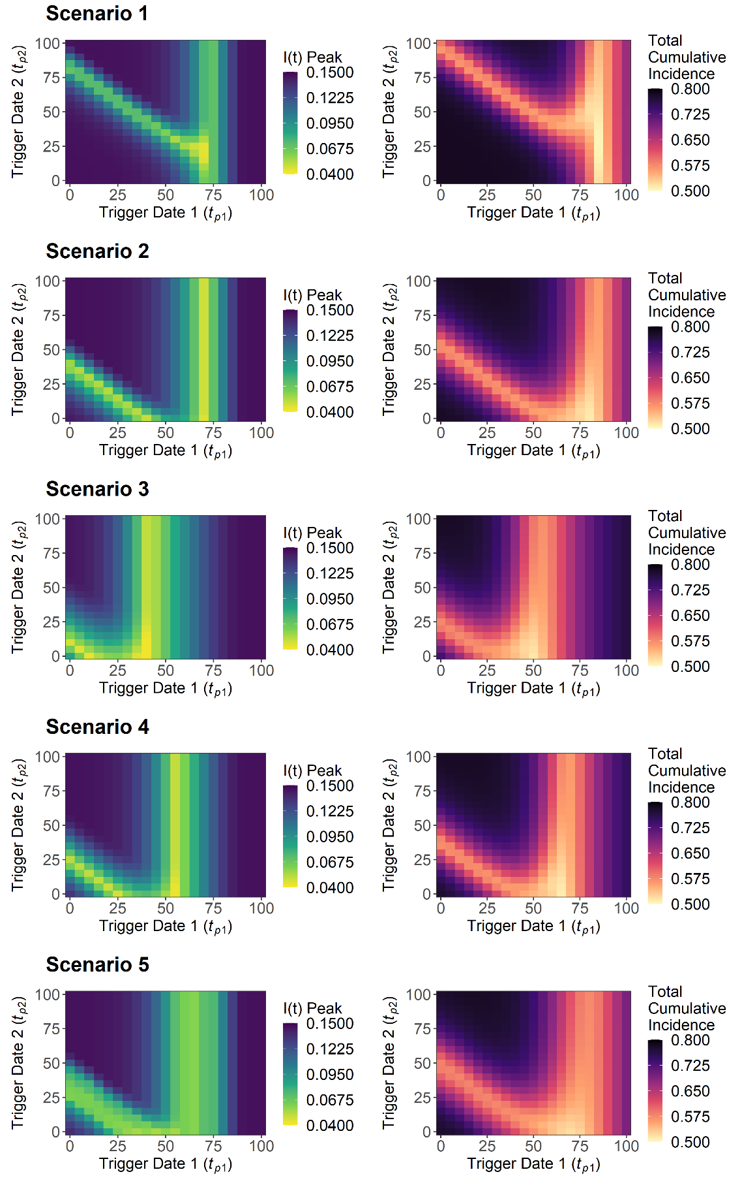

**Figure 5. Sensitivity analysis for maximum I(t) peak, *Imax*, and total cumulative incidence, Ic(∞), for intervention 1 trigger date, *tp1*, and intervention 2 trigger date, *tp2*. This was explored for the five intervention scenarios.** To ensure comparable overall magnitude of interventions of over the intervention duration, the intervention duration of Scenarios 2, 3, 4 and 5 were doubled relative to scenario 1 (12 vs 6 weeks). All scenarios are therefore comparable for a given parameter value combination with heatmap legends remaining constant.

A large range of trigger points for intervention 2 (1 ≤ *tp2* ≤100) were optimal to minimise *Imax* and *Ic(∞)*, on the condition that the optimal trigger point for intervention 1 was achieved (*tp1* = 65). This was found to differ if a suboptimal *earlier* intervention 1 trigger point was chosen, with only a narrow selection of optimal intervention 2 trigger points able to compensate for the suboptimal *tp1* value. The choice of a *later* than optimal intervention 1 trigger was found to completely negate the ability for an intervention 2 trigger to prevent increases in *Imax* and *Ic(∞)*, suggesting that it is better to introduce the initial intervention earlier, rather than later, if the optimal intervention 1 trigger point is unknown. Extending the duration of intervention 1 and 2 did little to alter the optimal trigger points for either scenario (**Figure S5-14**).

A sensitivity analysis was next conducted to explore the optimal parameter space for the lockdown related scaling factor for: 1) Intervention 1, *cmin1*, and 2) Intervention 2, *cmin2*, to minimise *Imax* and *Ic(∞)* outcome measures (**Figure 6**).

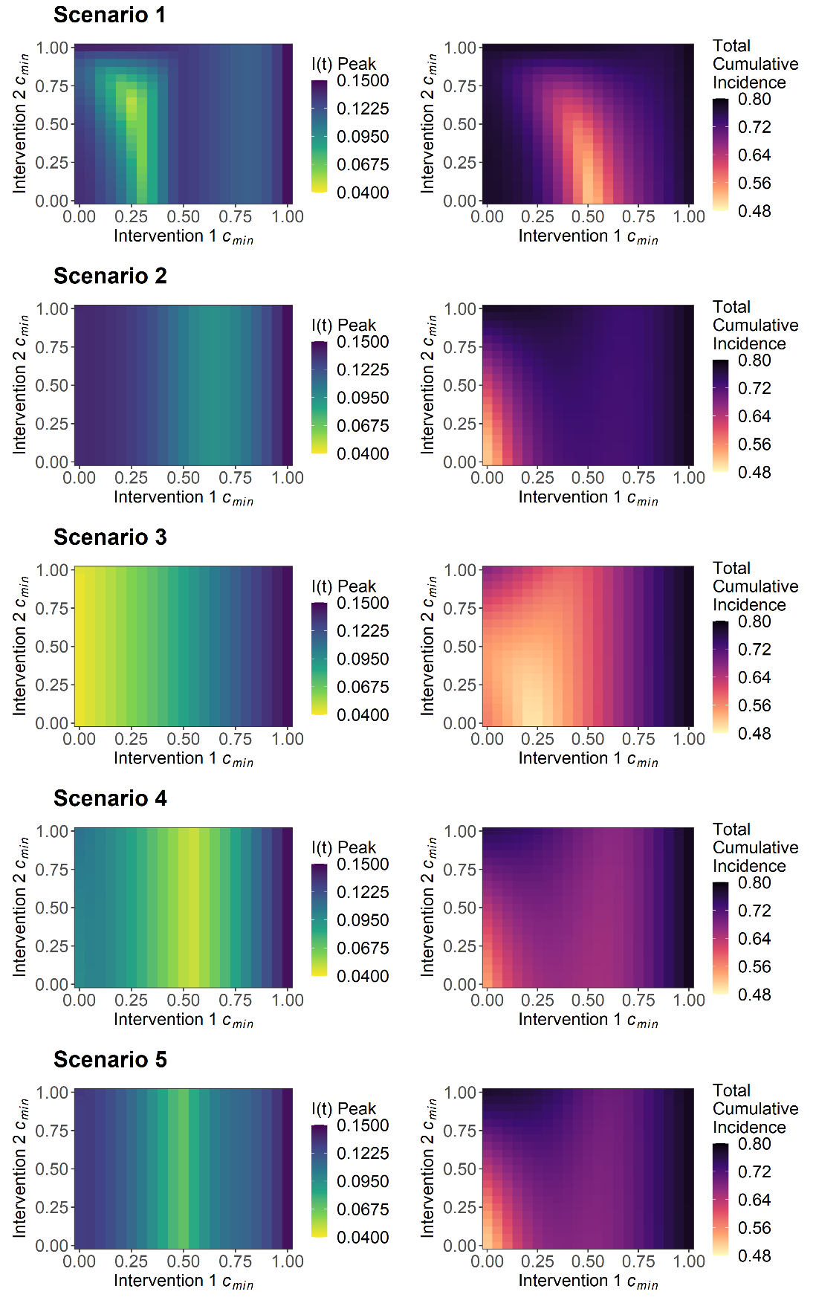

**Figure 6. Sensitivity analysis for maximum I(t) peak, *Imax*, and total cumulative incidence, *Ic(∞)*, for the minimum value of lockdown-related scaling factor for intervention 1, *cmin1*, and intervention 2, *cmin2*. This was explored for the five intervention scenarios.** To ensure comparable overall magnitude of interventions of over the intervention duration, the intervention duration of Scenarios 2, 3, 4 and 5 were doubled relative to scenario 1 (12 vs 6 weeks). All scenarios are therefore comparable for a given parameter value combination with heat map legends remaining constant.

Optimising the magnitude of intervention 1 was found to be more critical to minimise *Imax* and *Ic(∞)*, with a large range of optimal magnitudes possible for intervention 2 (0 ≤ *cmin2* ≤ 1), if the magnitude of intervention 1 is sufficiently optimised. Scenario 1, 2, 4 and 5 were characterised by an intermediate optimal intervention 1 magnitude **()**. Scenario 3 displayed subtly different dynamics, with intervention 1 ideally being as strong as possible (*cmin1* → 0) to optimise reductions to both *Imax* and *Ic(∞)*. This analysis was expanded for: 1) Intervention 1 duration, *dt1*, and 2) Intervention 2 duration, *dt2*, with increases in the duration of intervention 1 allowing for greater reductions to *Imax* and *Ic(∞)* for a given *cmin1*/*cmin2* parameter space compared to baseline parameters (**Figure S15-24**). The exception was scenario 3, with increases in intervention 1 duration resulting in detrimental increases to possible *Imax* and *Ic(∞)* values.

We next explored a modification of the multi-intervention model, with a sensitivity analysis conducted to identify the optimal parameter space for … and … for intervention 1. Following the cessation of intervention 1, we model a flat indefinite reduction to intervention 2. This represents the time taken to prepare for the build-up of a more sustainable intervention, such as test, track and trace capacity, while optimising intervention 1 to minimise Imax and ic().